Circular Public Procurement in the Baltic Sea Region

Newsletter 2 /October 2018/ Circular PP

Dear readers,

Welcome to the second issue of the Circular PP project newsletter. As well as recap the subject of the Circular PP project, this newsletter presents an overview of many of the actions that have taken place in the period June to October 2018. Enjoy!
What is Circular economy?
A circular economy approach is an alternative to the “make, use, dispose” model, which aims to keep products and materials in the value chain for a longer period and to recover raw materials after the lifetime of the products for their next use.
What is Circular procurement?
Applied to public procurement, it is known as a different way of acquiring goods and services that promotes consideration of the whole lifecycle of products throughout their supply chain.
By experimenting with non-conventional business models, circular procurement aims to lead the way to a circular economy.

The approach of the Circular PP
For the achievement of developing an adequate framework for circular procurement, the project team will follow a four steps approach:
- The study of the current state of knowledge on public/circular procurement.
- Building necessary capacity on circular procurement for all relevant stakeholders.
- Delivery and Implementation of pilot public procurement programs.
- Disseminating widely the project outcomes.

Activities in Ciruclar PP

Event at Aalborg's Sustainability Festival
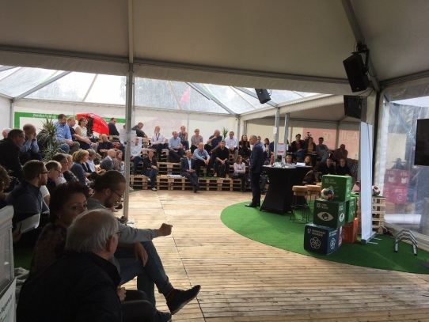
On 13th September, 130 people participated in a large meeting of circular economy stakeholders - Aalborg's Sustainability Festival - organised by the Municipality of Aalborg; North Denmark EU Office (EENA) and Networks for Sustainable Business Development North Denmark (NBE). This is a private-public partnership, where companies can strengthen their competitiveness by combining business development and environmental improvements.

At the event, the Circular PP project and Aalborg Municipality's two future circular tenders on playgrounds and lifetime extension of ICT were presented. There was also a lively panel debate on circular topics such as how can public and private cooperation create circular economics.

The event was a part of Aalborg Municipality's Sustainability Festival, focused on sustainable initiatives taking place around the city in the field of environmental and social responsibility, thereby drawing attention to the many sustainability initiatives that already exist, as well as inspiring more future sustainable behaviour.

To read more, click here, or or find a wide variety of the highlights here. The whole event was also live-streamed, and can be viewed here.

Strategic workshop on circular public procurement in Aalborg

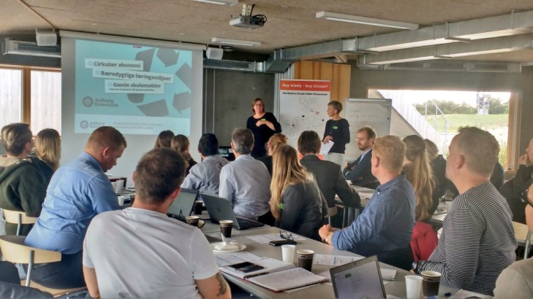
On 25th September, the Municipality of Aalborg hosted it's second event on circular economy. The main aim of this event was to deliver a strategic workshop which introduced the concept of circular procurement and strategies for getting started to key stakeholders. Among the participants were procurers and environmental experts from several departments within the City, as well as other business and social organisations in the Aalborg area. During an interactive workshop, the experts from Aalborg, ICLEI and PIANOo woked with participants to brainstorm how to take forward circular procurement pilots as part of Circular PP. The North Denmark EU Office (EENA) presented also the '7 Step Plan' for increased market involvement - the first step of which had been completed during the Aalborg's Sustainability Festival (see above).

Interested in knowing more? Please, click here.

Aalborg University lectures for EMSS students

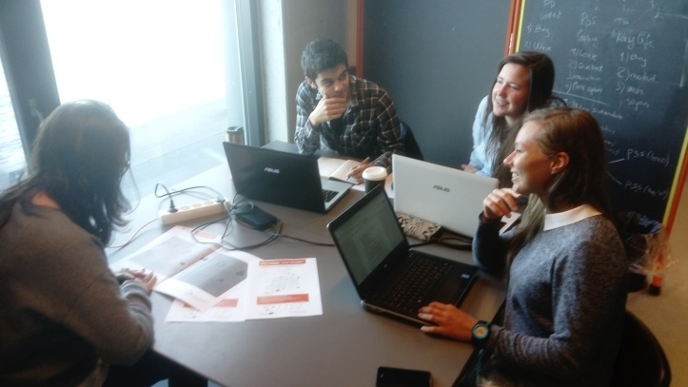
Students at Aalborg University from the Master’s program on Environmental Management and Sustainability Science (EMSS) are exploring how Aalborg University can use a Product-Service System approach for purchasing furniture. On 15th October a lecture took place where students were introduced to public procurement practices and how sustainability can be included in public procurement, as well as best practice examples of sustainable public procurement.
Market dialogues for “non-new” furniture

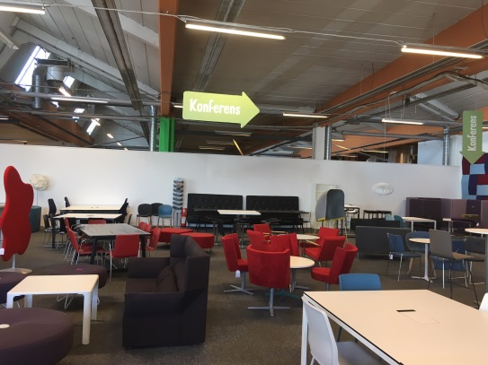
On a hot summer day, Victoria Boysen and Emma Börjesson from the Circular PP project team, together with 3 other employees from the city of Malmö, went on a tour to visit four companies with focus on “non-new” furniture. The four companies all are located in The Malmö area.
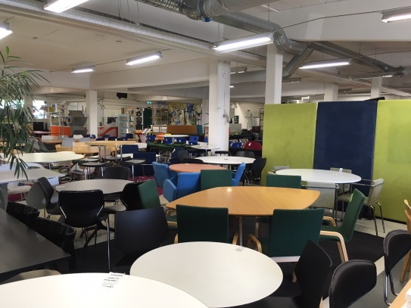
This visit really helped Malmö understand how much “non-new”-furniture exists in Sweden. Some of the companies had storerooms which were almost as big as an any small furniture company. The furniture often comes from office/workplace that has been moved/renovated/shut-down, and most of the furniture is hardly damaged at all. Some of the companies that Malmö visited also had an in-house upholsterer that could refurbish and remake the furniture. All the company representatives visited where very happy that City of Malmö is now taking steps toward a more circular furniture model, and great conversations were had with all the suppliers - some were almost too long and it was a rush to get to the next visit!

Pļaviņu food procurement – good practice
Photo: Katrina_S (on pixabay.com)
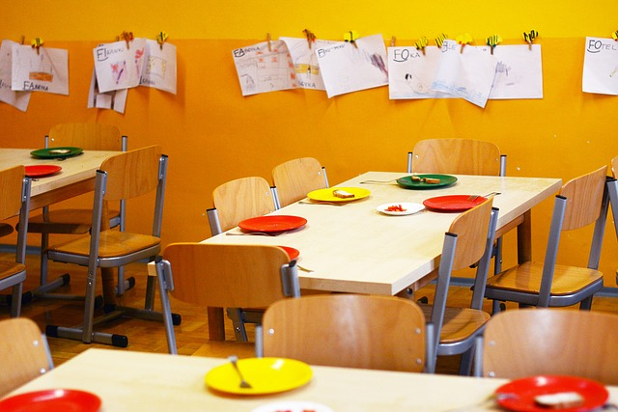
„Catering services in the Pļaviņu region gymnasium“ is the first example of a circular public procurement coming out of the Circular PP project. The organizer of procurement was city of Pļaviņas (Latvia). As well as price, the selection criteria of procurement referred to nutritional quality, compliance with a healthy diet, the number of certified products in menu (especially organic), environmentally friendly transportation (under 50 km), and participation in the “School Fruit” programme. As a result of this procurement, the pupils will receive proper meals consisting of, among other things, seasonal fruits and vegetables, and organic milk (at least 50%). The meals will be served without use of disposable plastic containers, and the services will be evaluated twice a year by the pupils. One of the important requirements referred to the waste management. In this procurement, the service provider was responsible for sorting the waste (biological, packaging, and other) according to the waste manager's instructions. The provider also has to carry out an inventory of waste generated in the kitchen and catering every six months, analyze this, and agree an action plan for waste reduction with the contracting party. The customer also has the possibility to indicate the using of surplus food. Finally, the provider was required to inform the contracting authority about the most important actions for the prevention of food waste. The procurement has a series of requirements for quality assurance activities, including: attending meetings with parents and teachers and providing information, immediately eliminating deficiencies in case of complaints, and providing the list of the suppliers of certified products.

Mentoring program in City of Malmö

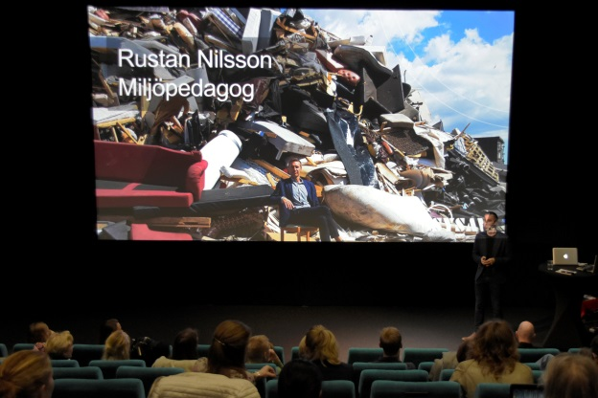
On 19th October, the City of Malmö arranged an awareness raising seminar on the importance of Circular Economy. The participants focused on waste management problems, and it was an opportunity to exchange ideas and propositions, and to discuss already existing initiatives on CE. The seminar was opened by mayor of Malmö - Katrin Stjernfeldt Jammeh - who encouraged all participants to try a new solution to challenges. The seminars will be organized periodically: the next two events will be held on 5th November and on 21st November.

Circular PP project presentation at the European Resource Efficiency Knowledge Centre (EREK)

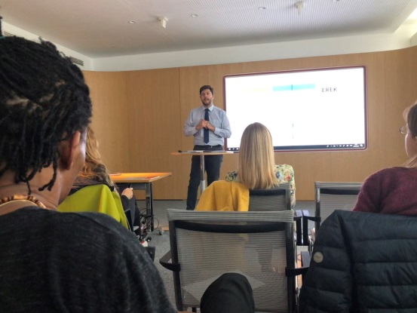
EREK organized a workshop October 22nd 2018 in Vienna, Austria. With the heading: “Let’s help SME’ to go circular.”
Brian Sørensen, International Network Manager from Enterprise Europe Network, North Denmark EU Office, introduced the workshop participants to the CPP project: “New opportunities and requirements for SME’s”. The workshop appreciated the efforts of the CPP project to contribute to capacity building and a greener future. In general the participants discussed different ways and tools to support SME’s to become more resource efficient. One discussion point was that resource efficiency of course is important, but that circular economy is more than that, looking at SME’s business models and the whole value chain of SME’s.
EREK is an initiative of the European Commission to help European companies, especially SMEs, save energy, material and water costs. EREK provides tools (e.g. Self-Assessment Tool for SMEs), information and business opportunities demonstrating new and better ways to be resource efficient and to benefit from circular economy business models. The EREK initiative was launched in February 2018 at the Circular Economy Stakeholder Platform (CESP) Conference in Brussels.
Photo text: Introduction by Mr. Agis Evrigenis, Project Director of EREK

In brief
- On 3rd-5th of October in Nijmegen (the Netherlands) the EcoProcura took place. This was a perfect opportunity to promote Circular PP project. Birgitte Krebs Schleemann from City of Aalborg hosted a Market Lounge table on Circular PP, introducing the project and discussing circular procurement with experts and procurers from across Europe.
- Birgitte Krebs Shleemann from City of Aalborg spoke at a Live Market Engagement for the sustainable procurement of ICT, on the growing need for circular ICT solutions and Aalborg's plans to pilot extended lifetime of ICT products as part of the Circular PP project.

What are we doing in the future?
- During the Polish Circular Week, which will be held on 25th October in Warsaw, representatives of project partner RRDA will present the Circular PP project.
- On 1st – 15th November, the Technical University of Riga (Latvia) will organize the lectures on the circular economy (Lekcija par Aprites ekonomiku) – more information about the event: http://cf.rtu.lv/2018/10/aprites-ekonomika-latvija/
- The second awareness raising seminar - 5th of November, City of Göteborg. The main subject will be related with the program “Circular Göteborg”. During the event six companies will present their circular business models and share challenged and successes.
- The third awareness raising seminar - 21st of November , City of Malmö. This seminar, led by Circular PP mentors, will focus on using tools and guidelines to conduct a circular procurement.
- The representatives of RRDA are getting ready to host the 10th Annual Forum of the EU Strategy for the Baltic Sea Region (EUSBSR) which will be held on Poland on 12-13th June 2019. More information on the website: https://www.balticsea-region-strategy.eu/news-room/news

Circular PP international partner meetings:
Arnhem, the Netherlands 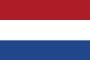
On 1st – 3rd October, the Circular PP project Partners met at the third meeting organized by the Ministry of Infrastructure and Water Management in Arnhem (the Netherlands), to discuss the actual status of the project and (perhaps most importantly) to acquire knowledge about the good practices in circular economy in public procurement.
At the meeting, a representative from the Managing Authority/Joint Secretariat (MA/JS) joined the Partners who, among other things, got useful information about the requirements and expectations MA/JS have for projects that receive funding from Interreg. It was also very nice to meet the contact and it always makes it easier to communicate. It is highly appreciated that MA/JS prioritizes these visits.
During 3rd Partner Meeting project team participated in study tour to new head office for the energy grid company Alliander in Duiven, close to Arnhem. The office has been renovated in accordance to rules of circular economy (Interested in knowing more about study visit? Please, click here).

The fourth partner meeting will take place in Spring 2019, in Malmö.

Want to know more about the Circular PP project? Please visit our:
- web-page: www.circularpp.eu
- Facebook profile: https://www.facebook.com/pg/CircularPP/community/?ref=page_internal
- LinkedIn: https://www.linkedin.com/company/circular-pp-project/
- Twitter: @circular_pp
- YouTube: https://www.youtube.com/channel/UCd2mijuQS7UuGJFgscwiYYA

Partners in the project
Ten partners from seven countries take part in the project:

DENMARK: City of Aalborg (AAL) | 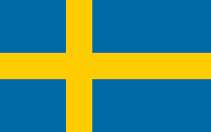  SWEDEN: City of Malmo (MAL) | DENMARK: Aalborg University (AAU) | 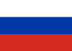  RUSSIAN FEDERATION: Saint Petersburg Campus of National Research University Higher School of Economics (HSE) | LATVIA: Latvian Environmental Investment Fund (LEIF)
POLAND: Rzeszow Regional Development Agency (RRDA) | 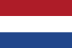NETHERLANDS: Rijkswaterstaat – Ministry of Infrastructure and Water Management (RWS) | FINLAND: Finnish Environment Institute (SYKE) | LATVIA: Latvian Chamber of Commerce and Industry (LCCI) | DENMARK: North Denmark EU-Office (EENA)

There is also an engagement of 21 associated organisations from 7 countries, interested in circular procurement, sought for further exploitation of project outcomes.
If you want to sign up to newsletter, click here.

